Team #2
Library Management System
Software Design Document

Name (s): Jorge Bautista, Stephen Canavan, Célina L. Pinard, Jack Gustafson
Lab Section: CSC 445-01
Date: 04/06/2026

TABLE OF CONTENTS
TABLE OF CONTENTS 2
1. INTRODUCTION 3
1.1 Purpose 3
1.2 Scope 3
1.3 Overview 3
1.4 Reference Material 4
1.5 Definitions and Acronyms 4
2. SYSTEM OVERVIEW 5
3. SYSTEM ARCHITECTURE 6
3.1 Architectural Design 6
3.2 Decomposition Description 7
3.3 Design Rationale 9
4. DATA DESIGN 10
4.1 Data Description 10
4.2 Data Dictionary 11
4.3 Data Storage and Management 12
4.4 Data Security 12
5. COMPONENT DESIGN 12
5.1 Authentication Component 12
5.2 User Management Component 13
5.3 Book Management Component 13
5.4 Circulation Component 14
5.5 Reservation Component 14
6. HUMAN INTERFACE DESIGN 15
6.1 Overview of User Interface 15
6.2 Screen Images 16
6.3 Screen Objects and Actions 17
7. REQUIREMENTS MATRIX 19

1. INTRODUCTION

1.1 Purpose
The purpose of this Software Design Document (SDD) is to describe the system architecture, data design, component design, human interface design, and show a requirements matrix of the Library Management System (LMS). This document is based on the requirements defined in the Software Requirements Specification (SRS) document and acts as blueprint to show how the system will be created.
The intended audience for this document is the development team, course instructor, and any potential project stakeholders that are involved in the design, implementation, and or evaluation of the system. This document provides an in-depth view of the system components, interactions, and design decisions. This confirms that consistency and traceability requirements are satisfied throughout the development of this project.

1.2 Scope
This LMS is a centralized platform for a library to use. It is designed to manage library resources, users, and handle circulation of items. The system supports functions such as catalog searching, borrowing and returning. Additionally, it also provides user accounts for library patrons and administrative features for library staff. The primary goal of this system is to replace the manual processes that a physical library system would have. This would allow for increased efficiency and reduce human error.
This project is limited by the fact that no real payment processing will take place. No external systems will be implemented in connection with this system. There will be no mobile applications or mobile support for this system. Finally, this system is intended exclusively for academic use only within the confines of this CSC-445 Software Engineering class, not to be implemented in any real library or in place of any real library system.

1.3 Overview
This SDD is organized into several sections. Section 1 serves as an introduction to the design as a whole listing the purpose, scope, overview, reference materials, and a series of definitions and acronyms for reference. Section 2 is a system overview which gives a general description of the functionality, context, and design of this project. Section 3 covers the system architecture focusing in on the architectural design, description of decomposition, and design rational. Section 4 touches on data design and gives both a data description and a data dictionary. Section 5 is component design which takes a systematic look at each component’s design. Section 6 goes over the human interface design by looking at an overview of the user interface (UI), screen images, and finally screen objects and actions. This is followed by section 7 which is a requirements matrix, detailing cross references that traces the components and data structures back to the requirements in the SRS document.

1.4 Reference Material
The following materials were used in the development of this Software Design Document:
[1] IEEE Standard for Software Project Management Plans, IEEE Std 1058-1998, Institute of Electrical and Electronics Engineers, 1998.
[2] IEEE Recommended Practice for Software Requirements Specifications, IEEE Std 830-1998, Institute of Electrical and Electronics Engineers, 1998.
[3] IEEE Standard for Software Design Descriptions, IEEE Std 1016-2009, Institute of Electrical and Electronics Engineers, 2009.
[4] Software Requirements Specification (SRS) for the Library Management System, Version 1.0, March 2026, CSC445 – Software Engineering, Eastern Connecticut State University.
[5] Software Design Document (SDD) for the Library Management System, Version 1.0, Spring 2026, CSC445 – Software Engineering, Eastern Connecticut State University.
[6] CSC445 Software Engineering Project Description Document, Spring 2026, Eastern Connecticut State University.
These references provide the standards, requirements, and project context used to guide the design and development of the system.

1.5 Definitions and Acronyms
The following definitions and acronyms are used throughout this SDD:
Table 1. Definitions and Acronyms:
Term | Definition
SDD | Software Design Document. Defines the overall system design, architecture, components, and how the system is implemented.
SRS | Software Requirements Specification. Used to show the functional and non-functional requirements of this system.
SPMP | Software Project Management Plan. Represents how the project is organized, scheduled, and managed during development.
LMS | Library Management System. Represents a system that manages library resources, users, item circulation, and all associated processes.
IEEE | Institute of Electrical and Electronics Engineers. The organization that provides the standards used in software engineering documentation.
IEEE 1058 | IEEE Standard for Software Project Management Plans (IEEE Std 1058-1998).
IEEE 830 | IEEE Recommended Practice for Software Requirements Specifications (IEEE Std 830-1998).
IEEE 1016 | IEEE Standard for Software Design Descriptions (IEEE Std 1016-2009).
API | Application Programming Interface. Defines how the different components of a system communicate with each other.
RBAC | Role Based Access Control. Giving users limited access based on their role.
DBMS | Database Management System. The software that is used to store, manage, and retrieve data.
SQL | Structured Query Language. Used to perform operations on relational databases.
JSON | JavaScript Object Notation. Format used to structure and exchange data between multiple system components.
Component | A modular part of the system that performs a specific task or function within the overall system design.
Architecture | Represents the overall structure of a system, specifying how components are organized and how they interact.
RBAC | Role-Based Access Control. This controls the system’s access by only giving the necessary permissions to a user based on their role (e.g. staff, patron).
REST | Representational State Transfer. Defines the architectural style used for communication between the client and the server.
Patron | Registered library user. Within the system, they are a user that searches, borrows, and reserves for items within the LMS.
Staff | Employee of the library. Within the system, they manage inventory and perform administrative actions.

2. SYSTEM OVERVIEW

The Library Management System is a web-based platform built to streamline tasks and make running a library easier and more efficient. The LMS is an academic project for CSC-445. This system provides a suite of tools to handle catalog searching, borrowing, returning, user account management, and administrative tools. It serves two groups of users: members, for self-service searching, borrowing, and returning, and staff for providing administrative services and managing library resources and policies.

The LMS is built using a three-tier architecture, split into sections of front-end (UI), back-end (application), and database. The front-end UI communicates with the back-end logic via RESTful APIs to securely handle authentication, role-based access control, and rules. Persistent data, like user records, book metadata, and transaction logs are maintained within a PostgreSQL database and accessed via Object-Relational Mapping.

3. SYSTEM ARCHITECTURE

3.1 Architectural Design

The system architecture for the LMS is based on a modular client-server architecture. This architecture separates out the user interface, application logic, and data storage. It is designed to organize the responsibilities of each team member and support system functionality. The system is separated into three subsystems at a high-level. These include frontend, backend, and database. The frontend subsystem is responsible for the user interface and the user interaction which is designed for ease of use. The backend subsystem deals with the business logic, the API, and request processing to allow for seamless, fast, and efficient execution. The database subsystem is meant to handle storage and retrieval of data as well as maintain and reinforce data integrity allowing for a healthy system. These subsystems interact through RESTful APIs, which handle request and response communication. The user requests are sent from the frontend and move to the backend which then is sent to the database and then in reverse order back to the frontend after completing the request. This architectural design allows the system to support the key features of borrowing, searching, and account management.

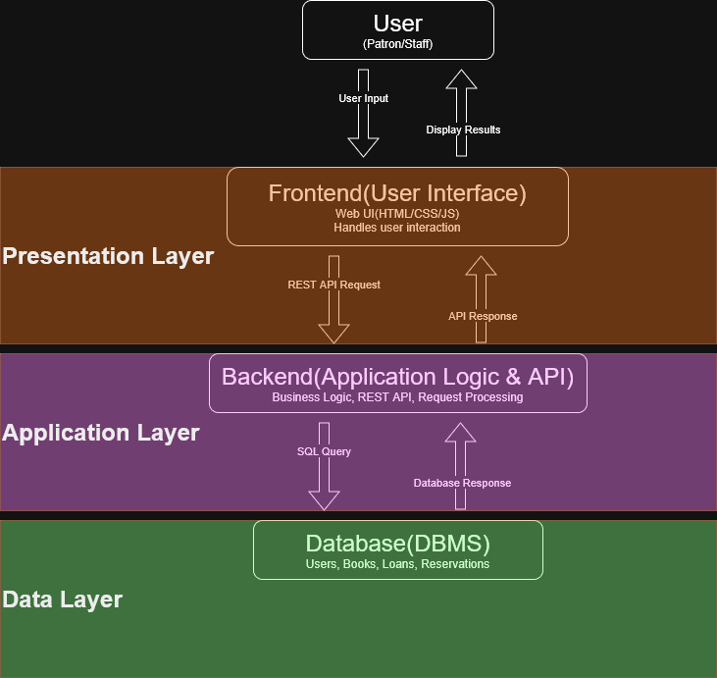
Figure 1. High-Level System Architecture of LMS
Figure 1 shows the high-level architecture of the system and how the user interactions flow from the user themselves, into the frontend, to the backend, through RESTful APIs, with the backend communicating with the database for data storage and retrieval. The response is then returned from the database to the backend and back to the frontend for display to the user.

3.2 Decomposition Description

The high-level subsystems that were described in Section 3.1 are further broken down into smaller components. This decomposition of the high-level systems follows a modular design approach where each component has a responsibility and improves the organization of the system. The backend subsystem is decomposed into several core components including, authentication and role-based access control, user management, book management, circulation management, and reservation management.
The authentication component is tasked with verifying and confirming the users identity and enforcing the RBAC. The user management component deals with user account creation, account updates, and role assignments. The book management component is responsible for handling book records, including, adding, updating, and retrieving book information. The circulation component manages the borrowing and returning of resources also tracking the due dates and loan status. The reservation component gives users the ability to reserve unavailable books along with managing the reservation status of the books.
The frontend subsystem is composed of several interface components. These components include searchable pages, account management, and administrative functions. The frontend communicates with the backend using RESTful APIs to send the users requests and display the results of those requests. The database subsystem is organized into several relational tables. The tables include the users, books, loans, reservations, and any outstanding fines. The relationships between these tables reinforce referential integrity ensuring data consistency. Together, all these components from the frontend, backend, and database work together to support system functionality and allow for modularity of the system.
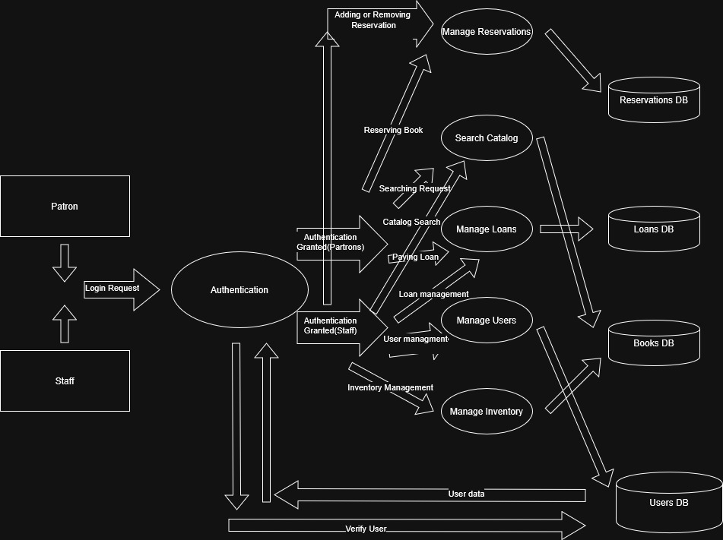
Figure 2. Level 0 Data Flow Diagram for LMS
Figure 2 shows the top-level data flow diagram for the LMS. This diagram shows how the external entities including patrons and staff interact with the main system processes which then communicate with the system database data stores.
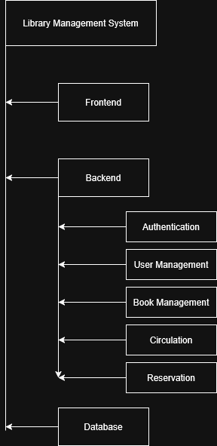
Figure 3. Structural Decomposition Diagram of LMS
Figure 3 shows the structural decomposition of the LMS. This diagram demonstrates how the system is divided into subsystems and how it is then further broken down into functional components within the backend of the system.

3.3 Design Rationale

The system architecture was selected because it aimed to support a modular design, organize responsibilities, and properly align with the project scope. The chosen architecture is sufficient for the LMS because it supports all the required functional and nonfunctional requirements as well as supporting multiple roles such as patron and staff. A major advantage of the design that was chosen is that it allows for separation of concerns. This means that the separation allows individual process to be debugged and updated easier than if they were all integrated.
Additionally, this architecture supports team members to work independently which is important due to the academic context of this project. This architecture however does introduce some tradeoffs such as more communication between components and slightly more complexity. For example, the frontend must go through the backend to directly access the data. This requires multiple API calls adding a layer of complexity. The alternative that was considered for this project was the monolithic approach compared to the current modular 3-tiered client-server architecture. The monolithic approach is simple to build initially, requires fewer components, and no API is required because everything is one big system. Ultimately this was not chosen for this project because it is hard to maintain, everything is tightly connected, which allows everything to break at once, and most importantly it is hard to work on independently. Overall, the current modular client-server architecture that was chosen provides the best balance between simplicity and structured design aligning well the scope of the academic based project.

4. DATA DESIGN

4.1 Data Description

The system uses an open-sourced relational database managed using SQL and accessed through an Object-Relational Mapping (ORM) layer. The database is responsible for storing, retrieving, and managing all persistent system data.

The primary data entities in the system include:
- User
- Attributes: UserID, Name, Email, Password, Role, Account Status
- Description: Represents all users of the system, including students, faculty, and administrators.
- Book
- Attributes: BookID, Title, Author, ISBN, Category, Availability Status
- Description: Represents all physical books available in the library.
- Loan (Borrowing Record)
- Attributes: LoanID, UserID, BookID, Borrow Date, Due Date, Return Date
- Description: Tracks books that have been borrowed by users.
- Reservation
- Attributes: ReservationID, UserID, BookID, Reservation Date, Status
- Description: Allows users to reserve books that are currently unavailable or be added to a queue for that book.
- Fine
- Attributes: FineID, UserID, Amount, Status
- Description: Stores information about penalties for overdue books.
- Inventory
- Attributes: InventoryID, BookID, Quantity, Location
- Description: Tracks the number of physical copies and their location.

Relationships between entities include:
- A user can have multiple Loans, Reservations, and Fines
- A book can be associated with multiple Loans and Reservations
- Inventory is linked to Book for tracking availability

4.2 Data Dictionary

Entity | Attribute | Type | Description
User | UserID | Integer | Unique identifier for each user
 | Name | String | Full name of the user
 | Email | String | User login email
 | Password | String | Encrypted password
 | Role | String | Defines access level (Admin/User)
 | Account Status | String | Active or suspended
Book | BookID | Integer | Unique identifier for each book
 | Title | String | Book title
 | Author | String | Book author
 | ISBN | String | Unique book identifier
 | Category | String | Genre/category
 | Availability | Boolean | Availability status
Loan | LoanID | Integer | Unique Identifier
 | UserID | Integer | Linked user
 | BookID | Integer | Borrowed book
 | Borrow Date | Date | Date borrowed
 | Due Date | Date | Return deadline
 | Return Date | Date | Actual return date
Reservation | ReservationID | Integer | Unique identifier
 | UserID | Integer | Linked user
 | BookID | Integer | Reserved book
 | Reservation Date | Date | Date reserved
 | Status | String | Pending/Completed
Fine | FineID | Integer | Unique identifier
 | UserID | Integer | Associated user
 | Amount | Float | Fine amount
 | Status | String | Paid/Unpaid
 | Issued Date | Date | Date fine issued
Inventory | InventoryID | Integer | Unique identifier
 | BookID | integer | Linked book
 | Quantity | integer | Number of copies
 | Location | String | Physical location

4.3 Data Storage and Management

All system data is stored in a relational database using structured tables with defined relationships and constraints. Data integrity is maintained through:
- Primary and foreign keys
- Referential integrity constraints
- Validation rules enforced at the application and database levels

The system uses an ORM layer to:
- Simplify database interactions
- Map database tables to application objects
- Improve maintainability and scalability

Data access is controlled through Role-Based Access Control (RBAC) to ensure that users can interact with data appropriate to their role.

4.4 Data Security

To ensure data security and privacy, the system implements:
- Encryption of sensitive data
- Passwords are stored using hashing algorithms
- Authentication and authorization mechanisms
- Role-based access restrictions
- Secure API communication (e.g., HTTPS)
Only authorized users (e.g., administrators) can modify critical system data such as inventory or user roles.

5. COMPONENT DESIGN

5.1 Authentication Component
The authentication component is responsible for verifying user identity and controlling access to the system. It ensures that only authorized users can perform actions that modify system data. This component supports login functionality, session management, and role-based access control (RBAC). It interacts with the user database data store to obtain the user's records. Finally, this component validates the role the user is assigned based on their credentials, giving them select permissions.
The pseudocode for the authentication component would look something like the following.
Input: Email, Password

Retrieve matching user record from database based on input email

IF user exists THEN
IF password matches user stored password THEN
Generate authentication token
Assign role to user (Patron OR Staff)
Grant access to system
ELSE
Return “Incorrect Password. Try Again”
ELSE
Return “User not found. Try Again”

5.2 User Management Component
The user management component handles user account creation, updates, role assignments, and account deletions. This component allows the staff to manage user records within the system. It interacts directly with the users database data store to obtain and edit user records. This component satisfies the requirement to allow library staff administrators to perform administrative functions on patron accounts.
The pseudocode for the user management component would look something like the following.
Input: User info(email, name, or id number)

IF creating new user THEN
Validate input
Add record to user database
ELSE IF updating user THEN
Locate user by email OR name OR ID number
INPUT: New info to update for user
UPDATE fields according to the input
ELSE IF deleting user THEN
Validate input
Confirm again that record will be removed from database
Remove user record from database
ELSE
Return “User not found. Try Again”

5.3 Book Management Component
This component handles book resource management within the system. It handles things such as adding, updating, or retrieving book information.

Input: book request
IF add book THEN
Insert book into database
ELSE IF update book THEN
Locate book by ID
Update fields
ELSE IF search book THEN
Query database by title/author/ISBN
Return results
END IF

5.4 Circulation Component
The circulation component handles borrowing and returning books. It additionally keeps track of transactions, enforces borrowing rules, and determines whether a book is available for borrowing. The pseudocode for this component would look like this:

Input: user ID, book ID
WHEN page loads
Check if book is available
Check user borrowing limit
IF valid THEN
Allow borrowing
Create loan record
Update book status to "On Loan"
ELSE IF invalid THEN
Allow Reservation component
ELSE
Return error
END IF
END IF
IF returning book THEN
Locate loan record
Update return date
Update book status to "Available"
END IF

5.5 Reservation Component
This feature provides the ability to reserve unavailable books. This component manages the reservation status and handles notifications when a book becomes available. If it has already been reserved, a user is added to a queue and will be notified when the book is available to them.

Input: user ID, book ID
Check if book is unavailable
IF unavailable THEN
Create reservation record
Set status to "Pending"
IF unavailable & reserved THEN
Assign user a queue number
Create reservation record
Set status to "Pending"
Return "You are {Queue number} in line for this book.”
ELSE
Return "Book is available"
END IF
WHEN book becomes available:
Notify user
Update reservation status

6. HUMAN INTERFACE DESIGN

6.1 Overview of User Interface

The LMS utilizes a Role Based Access Control layout strategy to ensure that patrons and staff only interact with the tools relevant to their specific tasks. The interface is divided into two primary experiences:

Patron Perspective
Patrons interact with a responsive web portal designed for both mobile and desktop use. The experience is optimized for ease of use, with a design that follows ADA standards for accessibility. Key functional areas include:
- Home Page & Catalog: A centralized, searchable database where patrons can discover items using parameters like Title, Author, or ISBN. The catalog provides real-time "Available" or "Checked Out" status indicators for every item.
- My Account Dashboard: A personal view where patrons independently manage their accounts. It displays a list of currently borrowed books, countdowns to due dates, and any pending fees.
- Reservations (Holds): Patrons can place holds on items currently in use or be placed in a line for an item. The system is designed so that a first-time user can successfully place a hold in under two minutes.
- Notifications & Feedback: The system provides automated feedback through "Hold Ready" alerts on the dashboard and outbound email or SMS notifications for due dates or reserved items.
Staff Perspective
Staff members use a secure administrative dashboard optimized for high-density data management on desktop displays (1920x1080). Their functionality includes:
- Circulation Desk: A dedicated area for processing high-volume tasks. It features Quick Scan fields that utilize barcode scanners to execute check-outs and returns by scanning a patron's ID and the book's barcode.
- Inventory Management: Tools for staff to push new item records or shipments into the database. Once added, these items immediately become visible to patrons in the search results.
- Policy & User Management: Staff can control circulation policies and manage user account permissions to ensure secure system operation.
- Reporting: The system generates high-contrast visual charts and reports, such as monthly circulation or overdue items, which can be exported to PDF formats.
User Feedback and Usability
The system is built to provide clear communication to all users:
- Error Handling: Patrons receive Guided messages such as "Try checking your spelling", while staff/experts receive technical error codes for troubleshooting.
- Efficiency: The interface is designed to minimize effort, requiring a maximum of three clicks to reach a "Confirm Borrow" button from a search result.
- Hardware Integration: To ensure a smooth workflow, the system supports peripheral hardware like receipt printers for automated silent print checkout slips and RFID readers for bulk item detection.

6.2 Screen Images
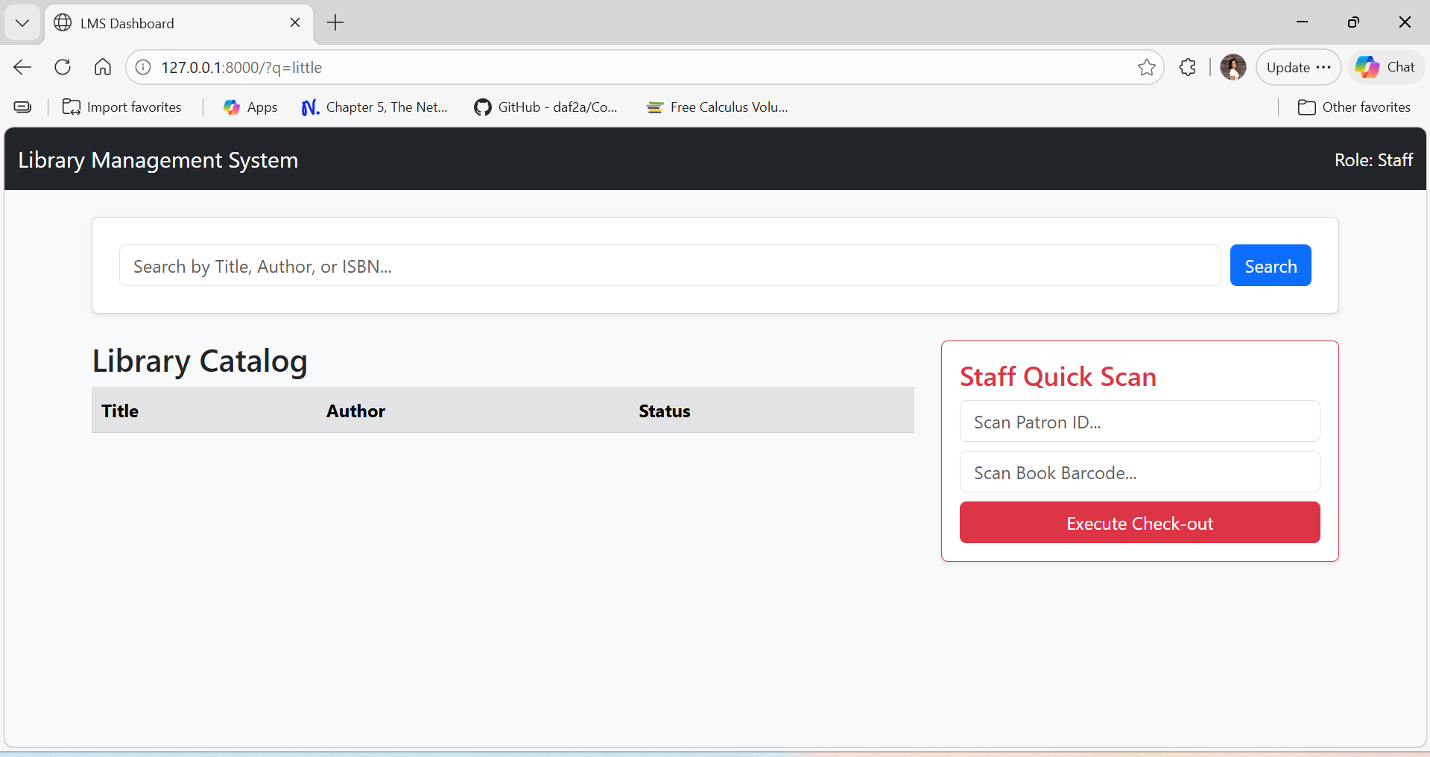
Figure 4. Screenshot of Staff Interface Draft
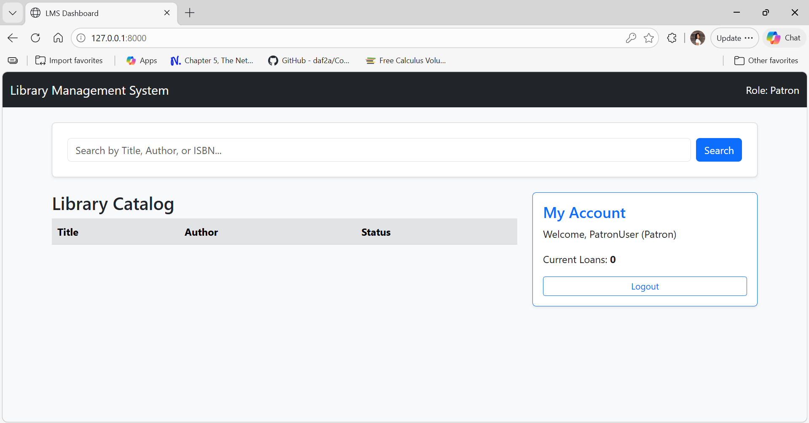

Figure 5. Screenshot of User Interface Draft

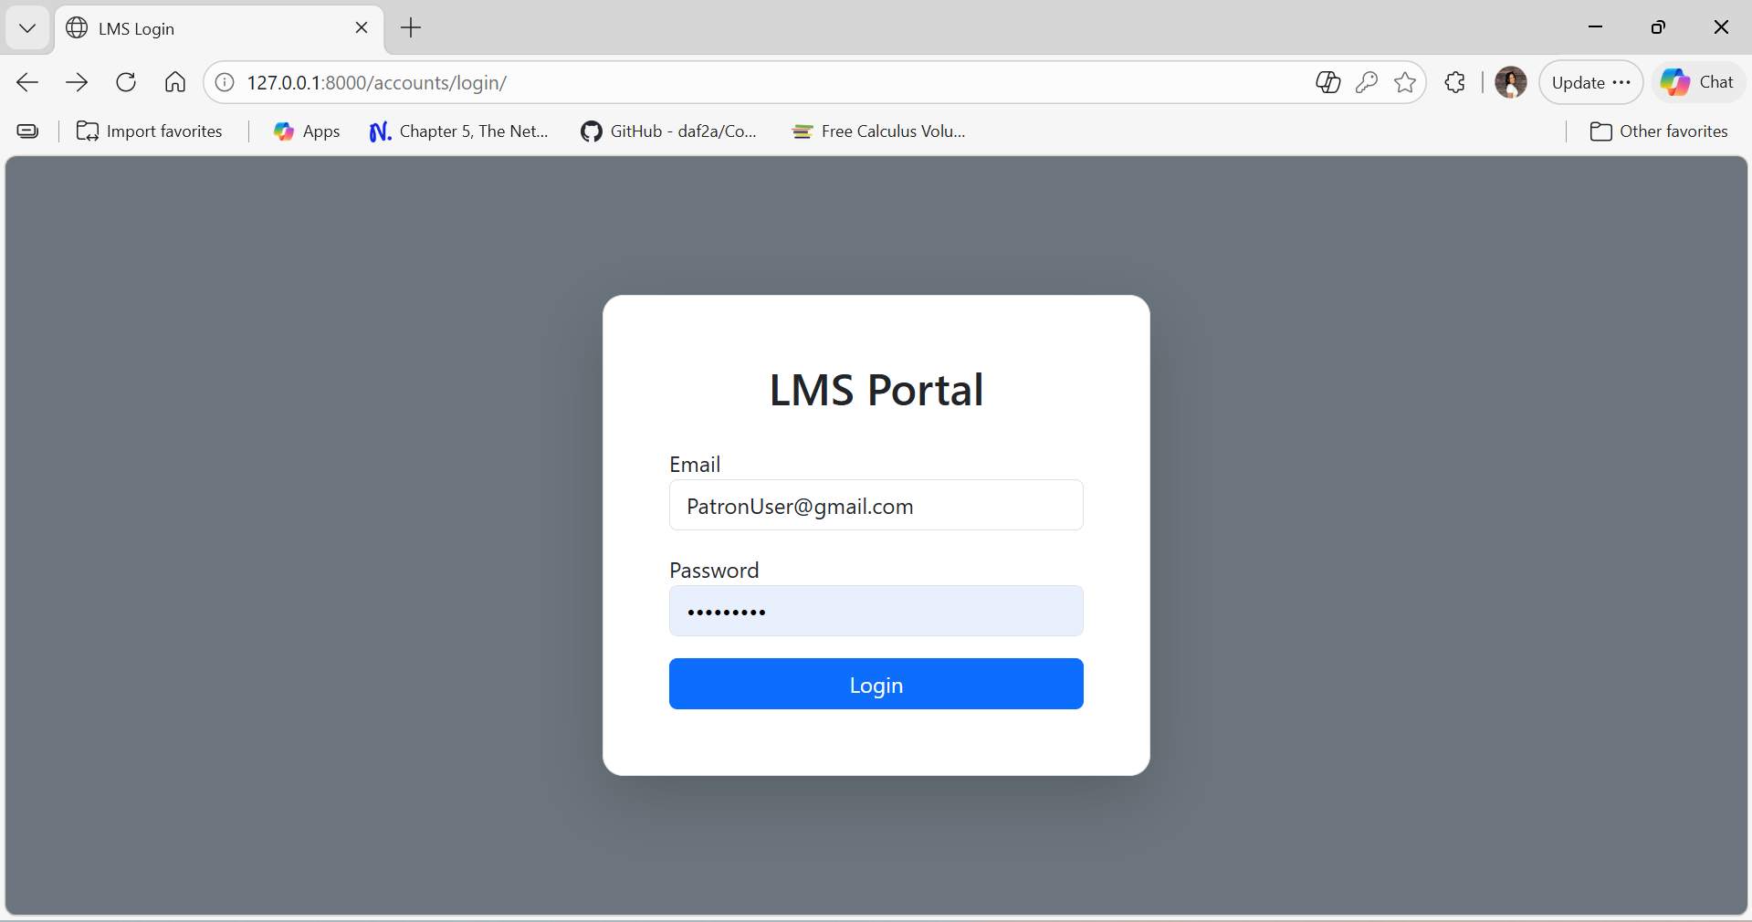
Figure 6. Screenshot of Login Portal Draft

6.3 Screen Objects and Actions
The following objects and associated actions define the user interaction:
Patron-Facing Screen Objects
- Search Bar:
  - Action: Patrons input text such as Title, Author, or ISBN and click Search.
  - System Response: The system executes a SELECT query using partial string matching to display a filtered list of matches with real-time availability status.
- "My Account" Button:
  - Action: Clicking this button allows patrons to view their personal lending history.
  - System Response: The system retrieves all loan and reservation records linked to that specific User ID to display current books, due date countdowns, and notifications.
- Patron Web Portal:
  - Action: General navigation through a responsive Web UI (HTML/CSS/JS).
  - System Response: Communicates with the back end via RESTful APIs to show real-time item availability and manage personal accounts.
Staff-Facing Screen Objects
- "Quick Scan" Input:
  - Action: Staff scan a book's barcode or manually enter an ID.
  - System Response: The system checks business rules such as fine limits or book counts and, if clear, creates a new record in the Loans table, shifting the item status to "On Loan".
- "Undo" Button:
  - Action: Staff can click this button during bulk inventory updates.
  - System Response: Reverts the last transaction to prevent data entry fatigue and errors.
- Administrative Dashboard:
  - Action: Use of secure tools for inventory management, policy setting, and reporting.
  - System Response: Features data tables for cataloging and dashboard widgets for system analytics and reports.
System-Wide Objects
- Status Indicators:
  - Object: Visual, color-coded availability tags.
  - Action/Feedback: Provides immediate visual feedback indicating if an item is "Available" or "Checked Out".
- Notification Engine/Alerts:
  - Action: Triggered by circulation logic when specific rules such as an item being overdue are met.
  - System Response: Sends automated Email or SMS alerts and displays "Hold Ready" notifications on the user dashboard

7. REQUIREMENTS MATRIX

Requirement ID | Requirement Description | System Component / Data Structure
FR-45 | Store information for users, books, borrow records, reservations, and fines. | Relational Database (SQL): Users, Books, Loans, and Reservations Tables.
FR-46 | Each user account shall have a unique identifier. | UserID (Primary Key): Unique identifier within the Users table.
FR-47 | Store bibliographic metadata including title, author, genre, and ISBN. | Catalog / Inventory Tables: Indexed fields for Title, Author, Genre, and ISBN.
FR-48 | Record checkout date, due date, and return date for each borrowing transaction. | Loans Table / Circulation Logic: loanRecord storing dates and itemStatus.
FR-55 | System shall require authentication for actions that modify system data. | Authentication Service: Identity Provider (IdP) using JWT or OAuth encrypted protocols.
FR-57 | Enforce role-based access control (RBAC) for staff and administrative functions. | RoleID / Administrative Dashboard: Permissions tiers distinguishing Patron and Staff sessions.
FR-59 | Operate in standard web browsers without additional software installation. | Patron Web Portal: Responsive UI built with HTML, CSS, and JavaScript.
FR-01* | Search by Title, Author, or ISBN. | Discovery & Search: Database Interface using indexed search parameters.
FR-02* | Automated user notifications (due dates, holds, system status). | Notification Engine: Outbound Messaging Interface (Email/SMS API).

